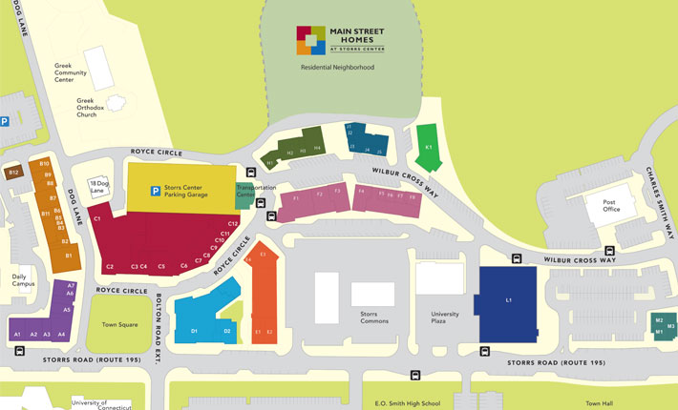
NEARBY SHOPS & RESTAURANTS

Storrs Center (above):
1 Dog Lane
[A1] Moe's Southwest Grill – American-Mexican fast food ($)
[A2] 7-Eleven – convenience store
[A4] Dog Lane Café – very good café with great food and coffee; also has beer and wine ($$)
[A5] Subway – sandwiches ($)
[A6] Insomnia Cookies – cookies; open until 3AM ($)
[A7] Mooyah Burgers & Fries – fast food burgers ($)
9 Dog Lane
[B1] Geno's Grille – good Italian restaurant ($$$)
[B5] Bank of America ATM – ATM; only opens with BoA card
[B10] Husky Pizza – pizza ($)
1 Royce Circle
[C3] Ballard Institute and Museum of Puppetry – nationally famous puppetry museum
[C11] Storrs Wine and Spirits – liquor store; open until 9PM

8 Royce Circle
[D1] Bruegger's Bagels – bagels and sandwiches ($)
[D1] Jamba Juice – smoothies ($)
[D2] CVS Pharmacy – convenience store
12 Royce Circle
[E1] Dunkin’ Donuts – coffee, donuts and breakfast food ($)
[E2] Gansett Wraps – great wraps, incl. vegan options ($)
[E3] Blaze Pizza – build your own pizza from 40 toppings, as many as you want for $7.95 ($)
33 Wilbur Cross Way
[F1] Grille 86 – sports bar with nice food ($$)
[F2] Kathmandu Kitchen – very good Nepalese and Indian food; also has a small bar ($$)
[F4] Tang Karaoke & BBQ – Chinese skewer BBQ and noodle dishes, plus booth karaoke! ($$)
40 Wilbur Cross Way
[H1] Tea More Cafe – boba/bubble tea and Asian food ($)
34 Wilbur Cross Way
[J1] Ice Monster – Thai style ice cream ($)
[J2] BLISS – clothing thrift store
1220 Storrs Road
[L1] Price Chopper – grocery store
1206 Storrs Road
[M3] Wingstop – chicken wings in many sauces ($)
Storrs Commons (in between D1/L1 on map above):
Chang’s Garden – Chinese food, banquet dinner here on Saturday ($$)
Starbucks – coffee, some small food ($)
Oriental Café II – Chinese and Japanese food and sushi ($$)
Bonchon – Korean fried chicken and some other Korean dishes ($$)
J&C Pho Asian Garden – pho and dumplings ($$)
Little Aladdin Mediterranean Grill – Mediterranean cuisine ($$)
DP Dough – take out calzones ($)
Randy’s Wooster Street Pizza – pizza ($$)

Off Campus (10-20mins by car away):
Maharaja – Indian food ($$) 466 Storrs Rd, Mansfield Center 06250
Willimantic Brew Pub – good pub food and craft brews ($$) 967 Main St, Willimantic 06226
Cafemantic – fantastic small plate restaurant ($$$) 948 Main St, Willimantic 06226
Oriental Café – Chinese, Japanese, Thai and sushi; better than one in Storrs ($$) 1257 Main St, Willimantic 06226

